Title:

**Dynamics of *Teleaulax* cryptophytes during red water blooms in the Columbia River Estuary.**

*Authors:*

Maria Hamilton 1,2, Joseph Nedoba 3, Katie Maxey 4, Rhonda Morales 1, Tawnya Peterson 3, Megan Schatz 1, Jarred Swalwell 1, Peter Zuber 4, E. Virginia Armbrust 1, Francois Ribalet 1*

*Affiliations:*

1 School of Oceanography, University of Washington, Box 357940, Seattle, WA 98195 USA

2 Present address: Ocean Sciences Department, UC Santa Cruz, 1156 High Street, Santa Cruz, CA 95064

3 To Be Completed

4 Institute of Environmental Health, Oregon Health & Science University, Mail code HRC3, Portland, OR 97239 USA

* Corresponding author: ribalet@uw.edu

**ABSTRACT (one page)**

Key results: We have found that there is a significant positive correlation between the abundances of the free-living *Teleaulax* cryptophytes and *M. major* populations during the bloom, which suggest a strong coupling between the availability of free-living prey and the abundance of *M. major*. Additionally, *Teleaulax* division rate was negatively correlated with pH while *Teleaulax* cell production (cell abundance x division rate) was positively correlated with concentrations of dissolved inorganic nitrogen (DIN), highlighting the importance of pH and nitrogen availability in the dynamics of *Teleaulax* and *M. major*.

Key words: cryptophytes; *Teleaulax; Mesodinium;* growth rates; SeaFlow

**INTRODUCTION**

The common coastal ciliate, *Mesodinium major*, previously referred to as *Mesodinium rubrum* (=*Myrionecta rubra*) (Lohmann, 1908; Jankowski, 1976), is among the marine microzooplankton that temporarily maintains the plastids of their cryptophyte algal prey, *Teleaulax amphioexa* (Herfort et al., 2011b). This association allows the ciliate to function as a mixotroph, capable of utilizing both phagotrophy and photosynthesis to acquire carbon (Crawford, 1989). Mixotrophic *Mesodinium* populationsare now understood to be important primary producers in coastal and estuarine systems (Stoecker et al., 1989, Herfort et al., 2012). However, little is known about the ecology and physiology of the *Teleaulax* cryptophyte prey and how their growth impacts the bloom dynamics of *Mesodinium*.

Massive *M. major* blooms occur each year in the Columbia River estuary and last for several months during the late summer and early fall (Herfort et al., 2011a), which shifts the estuary from net heterotrophy to net autotrophy (Herfort et al., 2012). The annual *M. major* bloom appears to be initiated during summer neap tides (Herfort et al., 2011a) when both tidal forcing and the seasonality of freshwater discharge result in an extended summer saltwater intrusion (Chawla et al., 2008) and a temporary decrease in turbulence. The bloom commonly starts in Baker Bay, where a shallow depth and high retention favor high cell abundances (>100 cells L-1) and fast growth rates (1.2-3.1 d-1) of *M. major*. Within a few weeks, this initial bloom spreads throughout the main estuary covering XX km (Herfort et al., 2011a). A decline in the abundance of small (<5 µm), free-living *Teleaulax* cells prior to the increase in *M. major* abundance observed in 2011 (Peterson et al., 2012) suggested a direct link between consumption of the cryptophyte prey and the initiation of an *M. major* bloom. In an Antarctic saline lake, however, an increase in abundance of cryptophytes preceded the increase in abundance of *M. rubrum* (van den Hoff et al., 2015), perhaps reflecting a different time point in bloom development. Thus, the underlying mechanisms remain unclear for the observed correlations between the abundance of free-living cryptophyte prey and the development of *M. major* blooms.

At least part of the complication comes from numerous factors that influence cell abundances, including cell division, cell mortality and high physical transport such as observed in the Columbia River estuary. We hypothesized that the rate of production of cryptophyte cells, rather than the standing stock, would better reflect the driving force for initiation of *M. major* blooms. Production rates incorporates both cell abundance and the rate of cell division, which until recently (Hunter-Cevera et al., 2014; Ribalet et al., 2015) was a time consuming measurement. It is now possible to use continuous flow cytometry measurements to estimate division rates based on changes in cell size distributions over the course of a day.

Here, we apply this approach to the study of cryptophyte division rates both in the laboratory and in the field. We determined how environmental conditions affected the division rates of the cryptophyte populations and cryptophyte cell production affects the dynamics of *M. major.* To do so, a 4 week-survey was conducted in 2013 during which nutrients, salinity, temperature, light irradiance, and abundances of cryptophytes and *M. major* were measured during red water blooms in the CRE. Daily division rates of cryptophytes were estimated using the size-structured division rate model (Sosik et al., 2003).

**METHODS**

**Study Area**

Samples were collected at 2.4 m depth for 1 month, 4 days a week, from September 11th to October 2nd 2013 using a continuous seawater flow-through system of SATURN03, a scientific station located on a dock near Astoria, OR (**fig. 1**) (REF?). Most discrete samples were collected during the turn of the high tide.

**Hydrological conditions**

Water temperature, salinity and pH were measured continuously using XXX. Photosynthetic Active Radiations were obtained from a mooring located X miles away from SATURN03.

**Nutrient concentrations**

30 mL surface water samples for nutrient analysis were taken in duplicate.

JN writes this

***Teleaulax* cell abundance**

Continuous measurements of cryptophyte abundances and cell size were made using SeaFlow, (Swalwell et al., 2011). The instrument was equipped with a 457-nm 300-mW laser (Melles Griot). Forward light scatter (a proxy for cell size), red and orange fluorescence were collected using a 457–50 bandpass filter, 572–27 bandpass filter and 692–40 band-pass filter, respectively. Seawater was prefiltered through a 100-µm stainless steel mesh (to eliminate large particles) prior to analysis. The flow rate of the water stream was set at 15 mL min−1 through a 200-µm nozzle for both cruises and for the laboratory experiments; this corresponded to an analysis rate of 15 µL min−1 by the instrument. A programmable syringe pump (Cavro XP3000, Hamilton Company) continuously injected fluorescent microspheres (1 µm, Polysciences) into the water stream as an internal standard. Data files were created every three minutes. Data were analyzed using the R package *Popcycle* version 0.2, which uses a SQLite relational database management system to retrieve flow cytometry data (<https://github.com/uwescience/popcycle>). A sequential bivariate manual gating scheme was used to cluster cryptophyte population based on orange fluorescence and forward light scatter measurements.

For the identification of *Teleaulax* cells, discrete flow cytometry samples were collected once a day during slack tide, fixed with 0.025% glutaraldehyde and stored at -80 ºC. Six months after sample collection, fixed samples were analyzed with a BD Influx cell sorter. 100 cells from the gated population of high-orange particles (assumed to represent *Teleaulax* cells) were sorted onto a glass slide. The cells were then examined under a Nikon Eclipse 80i epifluorescent microscope at 20x magnification and photographed using a Qimaging MicroPublisher 3.3 RTV camera.

**Estimates of division rates**

We used a size-structured matrix population model developed by Sosik et al. (2013) to estimate population division rates of *Teleaulax*. We implemented Sosik’s original Matlab model in an R package *ssPopModel* version 0.1.1, available on Github (<https://github.com/armbrustlab/ssPopModel>). The model is based on the assumptions that 1) cell growth is determined by light exposure, with other abiotic factors such as nutrient availability and temperature operating at longer time scales, 2) the probability of a cell dividing depends on size, 3) all cells within a discrete size class have the same probability to change to another size class, and 4) a cell divides into two daughter cells, each half the size of the mother cell. The model predicts the cell size distribution over the course of the day using the cell size/cell division relationships and the light-dependence of cell division.

*Estimated division rates in cultures.*

A non-axenic culture of the cryptophyte *Rhodomonas sp*. (CCMP 755) was grown in in the laboratory in natural seawater amended with f/2 nutrients at 13 °C with a 16:8 light-dark cycle of 100 µE m-2 s-1 provided by white fluorescent tubes. The culture was grown for 4 days in a 20-L batch culture and mixed with a magnetic carboy stir bar and analyzed with SeaFlow. On day 3, 1mL samples of the culture were collected in triplicate every 2 hours for 28 hours, fixed with 0.01% glutaraldehyde and stored in liquid nitrogen. One month after sample collection, fixed samples were stained with 0.01% green-fluorescing DNA stain SYBR Green I (diluted with dimethylsulfoxide) for 15 minutes at room temperature in the dark. Following the addition of fluorescent microspheres (1 μm, Polysciences) used as internal standard, stained samples were analyzed with a BD Influx flow cytometer. Data were obtained using the *Spigot Operating Software* version 5.0 (BD Biosciences) and analyzed using *FlowJo* version 9.7.2 (Tree Star). A minimum of 10,000 cells wascollected per sample. DNA frequency distributions were analyzed using *FlowJo* cell cycle platform to obtain cell fractions in G1, S, and G2+M phases. Division rates based on DNA distributions were computed as described previously (Carpenter and Chang, 1988).

*Estimated division rates in the field.*

The method used to estimatehourly division rates of *Rhodomonas* sp*.* in culture was applied to *Teleaulax* populations in the field. Daily-averaged division rates were calculated as the sum of hourly division rates over a 24-h period.

**Cryptophyte community composition**

*DNA extraction*

Sample volumes of 0.5-2.0 L were filtered with a 20 μm filter followed by a 0.2 μm Sterivex filter. The size fractionation was performed to separate the *Teleaulax* symbiont in *M. major* cells from free living *Teleaulax.* Filters were fixed with 2 mL of RNAlater and stored at -80°C until extraction.

Samples were extracted using the CTAB method (Li et al., XXXX). Briefly, the filters are suspended in buffer and proteinase K in 2 ml microcentrifuge tubes and incubated at 55°C overnight. After this incubation, 165 μL each of 5M NaCl and 10% CTAB were added and incubated for an additional 10 min at 55°C. Approximately 600 μL of chloroform was added and the samples were then vortexed for 75 seconds, followed by centrifugation (13,000g) for 10 min. The DNA of the aqueous layer was purified using a DNA Clean and Concentrate Kit (Zymo Research). The total extracts were stored at -20°C until further use.

*Identification of the cryptophyte nuclear 28S D2 element*

A *Teleaulax* specific genetic marker was used to distinguish between *T. amphioxeia* and other free living cryptophytes. This marker is the Unique Sequence Element (USE) found in the D2 region of the LSU rRNA sequence. The cryptophyte nuclear D2 region of the LSU was identified using the 28S D1-D5 sequence for the cryptophyte *Goniomonas truncata* (accession number FJ176709). A BLASTn search showed a large gap in sequence homology of around 300-400 bp near the 5’ end of the LSU. Primers were designed using Primer-BLAST to flank this gap region (crp28SF CTTGCTTGGGAATGCAGGTC /crp28SR TACGAGCCTCCACCAGAGTT). These primers were used with PCR to identify the LSU D2 of *Teleaulax*.Single cell PCR was performed on *M. major* cells from red water in the CRE collected in 2011 and 2014. The lab culture of the Antarctic strain of *M. rubrum* (CCMP2563) was used as a control, as it is fed with the cryptophyte *Geminigera cryophilia* (CCMP 2564)*.* The PCR protocol for the LSU D2 sequence identification is as follows: initial denaturation at 95°C for 3 min; 35 cycles of denaturation at 95°C for 45 sec, annealing at 50°C for 40 sec, and extension at 70°C for 2 min; and a final extension at 70°C for 7 min. The results of the PCR were visualized on a 1% agarose gel. The PCR products were purified (UltraClean PCR clean up kit, MoBio), ligated into a TOPO 2.1 vector (Invitrogen), and transformed into chemically competent *E. coli* cells (DH5α strain). The transformed cells were grown up overnight at 37°C on LB plates containing 40 μg/mL X-gal and 50 μg/mL Kanamycin. White colonies were selected and grown up overnight in a 37°C water bath shaker in 2X YT broth with 50 μg/mL Kanamycin. Miniprep (FastPlasmid Mini Kit, 5 Prime) was performed and the samples were sent to the Molecular and Cellular Biology Core of the ONPRC for sequencing. Sequences of around 650 bp were assembled and aligned using Geneious software.

Alignment between the *T. amphioxeia* and *G. cryophilia* D2 sequences identified a unique sequence element (USE) (Kahn et al., XXX) of around 220 bp. The *T. amphioxeia* USE was used as a species specific marker to track the free living cryptophyte and *M. major* in the estuary. The specificity of the USE was demonstrated using FISH on red water and lab culture samples. A FISH probe [TxD2 FISH (alexa 488 – AACACACGAGTTAAGATACCAATGGATCATTCACTCGCATGCCC)] was designed to hybridize to the 3’ end of the USE in *Teleaulax amphioxeia*. The probe was labeled with Alexa488 fluorophore. The probe was seen in the cytoplasm of both the ciliate and free cryptophytes in CRE red water, but not in the laboratory *M. rubrum* culture.

The 28S D2 sequence was extended to the 3’ end of the 18S rRNA using the general eukaryotic 18S primer BMB-CR (GTACACACCGCCCGTCG)to Crp28SR. This region includes the 5S and ITS2. The 18S rRNA sequence generated was identical to that of *T. amphioxeia*.

*Real Time PCR*

The distribution and size of the cryptophyte and specific prey population was monitored in environmental samples by qPCR. Analysis was performed on a StepOnePlus Real Time PCR system (Life Technologies) using SYBR Green as the reporter dye and the following protocol: initial denaturation at 95°C for 10 min; 40 cycles of denaturation at 95°C for 15 sec, and extension and data acquisition at 60°C for 1 min; followed by a melting curve analysis. The *Teleaulax* specific primers (TxD2 1F (TGAAAAAGGGCCTGAAATTG) /TxD2 USE 2R (ATCATTCACTCGCATGCCCC)) were used to amplify the USE of the prey cryptophyte. General cryptophyte primers (CrpSpecf 3F (GTTCTGAAGATGCTGGCACA)/ CrpSpecf 3R (GTTCTGAAGATGCTGGCACA)) were used to monitor total cryptophyte populations and calculate the ratio of prey to total cryptophytes. This sequence was downstream of the USE. Primers were designed using Primer-BLAST from NCBI and confirmed with PCR.

The Antarctic *M. rubrum* culture was used as a control (i.e., negative for prey specific and positive for general cryptophyte). All environmental total extracts were diluted 10 fold before analysis to remove interfering compounds. All standards, samples and water blanks were analyzed in triplicate and 1 μL of DNA template was used in each reaction. Standards for qPCR were constructed with the *T. amphioxeia* LSU D2 region cloned into a TOPO 2.1 vector. This plasmid was used for both primer sets as it contained the *T. amphioxeia* specific USE and a general cryptophyte sequences. A standard curve was generated from six standards with concentrations ranging from 9.289 X 106 – 9.289 X 101 D2 copies/µL. Concentrations of the standards were calculated from Kahn et al. (XXXX). Concentrations of USE copies were determined with the following formula:

Copies/mL = abc/d

Where *a* is the copies/μL determined from qPCR, *b* is the volume in μL the extracted DNA was re-suspended in, *c* is the dilution factor and *d* is the volume in mL of the water sample.

***Mesodinium major* cell abundance**

45 mL samples fixed with XX% glutaraldehyde were collected for *M. major* counts, stored at 4 °C and analyzed XX months later using FlowCAM.

TP writes this

**RESULTS**

**Environmental Data**

The Columbia River Estuary is a turbid and often highly stratified system characterized by its dynamic physical processes, short residence time (0.5-5 days) and strong influence from diurnal and semi-diurnal tides (Neal, 1972; Jay, 1984). Throughout the 4-week survey at SATURN03 (**Fig. 1**), surface water temperature and salinity were anti-correlated and oscillated with the tidal cycle, with high tide characterized by an influx of colder seawater, and low tide characterized by an increase of warmer freshwater. The highest surface water salinity and lowest temperature were observed during the second week (day 7-14) while the lowest salinity was observed on day 23-24, with little variations in temperature over the tidal cycle (**Fig. 2A**). The average surface water temperature and salinity during the survey were 17.5 °C and 12 psu, respectively. The variations of pH were correlated with tidal cycles, with values increasing during flood tides that ranged from 7.8 to 8.4 (**Fig. 2B**). The lowest pH values were observed at day 3 and increased progressively later on. A 6-fold change in the maximum PAR values was observed during the survey, with values ranging from 100-600 µE m-2 s -1 (**Fig. 2B**). Day 6-9, 16 and 23 exhibited the highest PAR values integrated over the daily cycle. Changes in phosphate and dissolved inorganic nitrogen (DIN as the sum of nitrate, nitrite and ammonium) concentrations co-varied throughout the survey, with nutrient concentrations stable during the first three day of the survey, increased by day 7, decreased during the second week (day 8-15) and remained relatively stable later on (**Fig. 2C**). DIN concentrations were negatively correlated with pH (R2 = 0.34, p< 0.05) (**Fig. S1**).

**Cell abundances**

The small size (<5 µm in length) and teardrop shape of the cryptophyte cell population sorted with the flow cytometer and observed under light microscope (**Fig. S2**) agreed with past observations of *Teleaulax amphioexa* cells (Peterson et al., 2012). We therefore assumed that the cryptophyte cell population measured by the SeaFlow represented *Teleaulax amphioexa* population during the survey.

Hourly-averaged cell abundances of *Teleaulax* measured ranged from 0.02 x 106 to 1.8 x 106 cells L-1, with an average of 0.29 x 106 cells L-1 (**Fig. 3**). Results from the SeaFlow were in excellent agreement with discrete samples analyzed by conventional flow cytometry (R2 = 0.83, p < 0.01, **Fig. S3**). Variations in cell abundance were not correlated with tidal cycle, though oscillations in abundance did occur within individual days. No significant correlation was observed between *Teleaulax* cell abundances and salinity or temperature (data not shown). The highest abundances of *Teleaulax* were observed during the first two days of the survey, with daily-averaged abundance of 0.52 x 106 cells L-1, (**Fig. 3A**). Week 2 (day 7-10) and week 3 (day 15-18) exhibited the lowest abundances, with an average of 0.08 x 106 cells L-1 and 0.09 x 106 cells L-1, respectively (**Fig. 3B and C**).

The abundances of *Teleaulax* at high-tide were comparable to the abundances of *M. major*, with values varying from 0.021 x 106 to 0.32 x 106 cells L-¹ during the survey (**Fig. 3**). A positive correlation between abundances of *Teleaulax* and *M. major* was observed during the survey (R2 = 0.51, p < 0.01) (**Fig. S4**). Except at day 10, abundances of *M. major* were lower than those of *Teleaulax*. Abundances of *Teleaulax* and *M. major* during the survey were not significantly correlated with environmental conditions such as nutrient concentrations (data not shown).

**Division rates and cell production**

To establish the accuracy of size distribution-based division rate estimates using SeaFlow measurements of forward-angle light scattering converted to cell volume using an empirical relationship (Ribalet et al. 2015), we compared size-based estimates of division rates (h-1) with cell-cycle based estimates of division rates for the cryptophyte *Rhodomonas*. The hourly division rates estimated using both cell cycle analysis and the model followed the same general trend throughout the experiment (**Fig.** **4**), although some discrepancies occurred around dawn (at hour 1, 3 and 27). The coefficients of determination R2 = 0.60 (p < 0.001) (**Fig.** **S5**) indicates that the model provides reasonable estimates of division rate for the cryptophyte *Rhodomonas* in culture*.* In the field, our limited access to the sampling site prevented us to use the cell-cycle method to validate our model-based estimates of division rates for the cryptophyte *Teleaulax*. Ding the 4-week survey, the size distribution of *Teleaulax* increased only throughout the day and decreased at night (**Fig.** **S6**), which is consistent with the model assumptions that photosynthesis and cell division are the main factors influencing the change of cell volume over the day/night cycle (Sosik et al. 2003).

Estimates of the daily division rates of *Teleaulax* cryptophytes ranged from 0.30 ± 0.08 d-1 to 1.67 ± 0.13 d-1 (**Fig. 5**), which correspond to 0.4 and 2.4 division per day, respectively. The highest division rate was observed at day 3 and coincided with the lowest pH values (**Fig. 2C**). Division rates were negatively correlated with pH during the survey (R2 = 0.41, p < 0.05) (**Fig. S7**), with decreasing division rates observed with daily-averaged pH > 8.0. No significant correlation was observed between division rates and other environmental factors such as temperature, PAR and inorganic nutrient concentrations (data not shown).

TRANSITION

Cell production (i.e., cell abundance x division rate) was negatively correlated with pH (R2 = 0.53, p < 0.05) and positively with concentration of dissolved inorganic nitrogen (R2 = 0.58, p < 0.01) (**Fig. S7**).

**Cryptophyte community composition**

The percent of *Teleaulax amphioexa* to the total cryptophytes ranged from 0.06% to 0.40% (**Table 1**), with the highest and lowest percent of *T. amphioexa* occurring during the first and second week of the survey, respectively, similar to the cell abundances of *Teleaulax* and *M. rubra* (**Fig. 3**).

MORE

**DISCUSSION**

The continuous method used in this study circumvents many of the limitations associated with traditional discrete sampling method when monitoring plankton populations in a dynamic system such as the CRE. Our results show that cell abundances of cryptophytes can shift dramatically over the course of just a few hours and highlight the importance of physical process in the dynamics of plankton population in the CRE. Such variability in cell abundance should be taken into consideration when interpreting results from data extrapolated from a few data points and emphasized the importance of continuous measurements for monitoring phytoplankton in the CRE.

The model utilized to determine division rates relies on a number of important assumptions, including the assumption that the population of interest consists of a single taxonomic group. It is possible that multiple taxonomic groups of cryptophytes with different physiologies are represented within the population of cryptophytes that we observe with SeaFlow, despite the consistent morphology seen among the sorted population. But we do not actually have any evidence that connects this possible model assumption violation to any potential errors in our division rate estimates. Furthermore, our validation of the model on a laboratory culture of cryptophytes confirms the model’s ability to accurately estimate the division rates of these eukaryotic phytoplankton

**Ecophysiology of the *Teleaulax* cryptophyte during the survey**

The cryptophyte *Teleaulax amphioexa* is a marine species distributed in coastal habitats worldwide. During our survey, no consistent increase in *Teleaulax* cell abundance was observed with seawater intrusion, and variations in abundances were not related to tidal cycle. These results suggest that *Teleaulax* distribution is very patchy within the CRE, and highlight the importance of physical transport in the dynamics of *Teleaulax* in the estuary, making interpretation of changes in cell abundance difficult.

To the best of our knowledge, this study is the first to attempt to estimate division rates of *Teleaulax* species in the field. Laboratory estimates of *Teleaulax amphioexa* division rates under nutrient replete conditions range from 0.7 to up to 1.57 d-1 (Nishitani et al., 2008; Berge et al., 2010; Rial et al., 2012). This is in good agreement with our highest estimate of 1.67 d-1 observed on day 3 of the survey, suggesting that cells at that time were growing near optimal growth conditions.

In the turbid waters of the Columbia River Estuary, light is generally considered to be an important factor limiting phytoplankton growth (Herfort et al., 2012). However, we did not observe a significant correlation between light intensity and division rates for *Teleaulax* cryptophytes estimated at 3 m depth during the survey, which support previous studies that showed that the photosynthetic machinery of cryptophytes is well adapted to low light conditions (Bergman et al., 2004). Instead, we observed a negative correlation between division rates of *Teleaulax* and pH during the survey. The negative effect of pH values above 8 on the division rates of *Teleaulax* was unexpected considering that a previous study did not observed any negative effects on their growth at pH > 8 (Berge et al., 2010) but showed that their growth was affected by low pH values (pH < 6.1). One explanation for this apparent discrepancy could be that nutrient availability may have still been in excess during their experiment despite the reduced solubility of nutrients at higher pH. During our survey, pH was negatively correlated with nutrient concentrations and cell production was positively correlated with DIN concentrations. These results suggest that elevated pH reduced the availability of DIN, whose concentrations became the dominant factor limiting the growth of *Teleaulax amphioexa* during the survey.

**Impact of *Teleaulax* cryptophyte on *M. major* abundances during the survey**

The abundances of *Teleaulax* cryptophytewere comparable to those of *M. major*. Assuming an ingestion rates between ~3.5 and 8.9 cryptophytes ciliate-¹ day-¹ by *M. major* (Yih et al., 2004; Hansen and Fenchel, 2006), our results suggest that abundances of free-living *Teleaulax* were limiting the abundance of *M. major*. The positive correlation between the abundances of *Teleaulax* cryptophyte and *M. major* supports such hypothesis. Using a FISH probe for the *Teleaulax amphioexa* 28S DNA, up to >20 *T. amphioexa* cells were observed within or attached to a single *M. major* cell (Peter Zuber, personal communication). This finding supports previous observations of *M. major* having the ability to retain cryptophytes attached to the ciliate's cirri during red water blooms in the CRE (Peterson et al., 2012). Alternatively, it is possible that ingested *T. amphioexa* cells can divide inside the ciliate (REF). While the ability of *Teleaulax amphioexa* to divide inside *M. major* has not yet been demonstrated in cultures, it has been observed in other single-celled endosymbiont-baring organisms such as XXX (Kodama and Fujishima, 2009; Johnson, 2011). But without a cultured representative of *M. major*, explanations as to the specific fate of *T. amphioexa*, either as a whole endosymbiont or as sequestered organelles, inside the ciliate remain speculative and are constrained by the limitations of field investigations.

To include

- discussion of cryptophyte community composition

**Conclusions**

Past studies on the *M. major* bloom in the Columbia River Estuary have hypothesized that the dynamics of the ciliate's cryptophyte prey may play a role in the proliferation of the bloom (REFS). Our results indicate that abundance of *Teleaulax* is limiting the development of *M. major* blooms.

**Acknowledgements**

Antonio, Michael, Joe and more…

**References**

Table

**Table 1.** Percent of *Teleaulax amphioexa* to the total cryptophytes during the survey.

|  |  |
| --- | --- |
| Date | % *T. amphioexa* to total cryptophytes |
| 9/11/13 | 0.40 |
| 9/13/13 | 0.18 |
| 9/20/13 | 0.06 |
| 9/24/13 | 0.08 |
| 10/1/13 | 0.23 |

**Figure Captions**

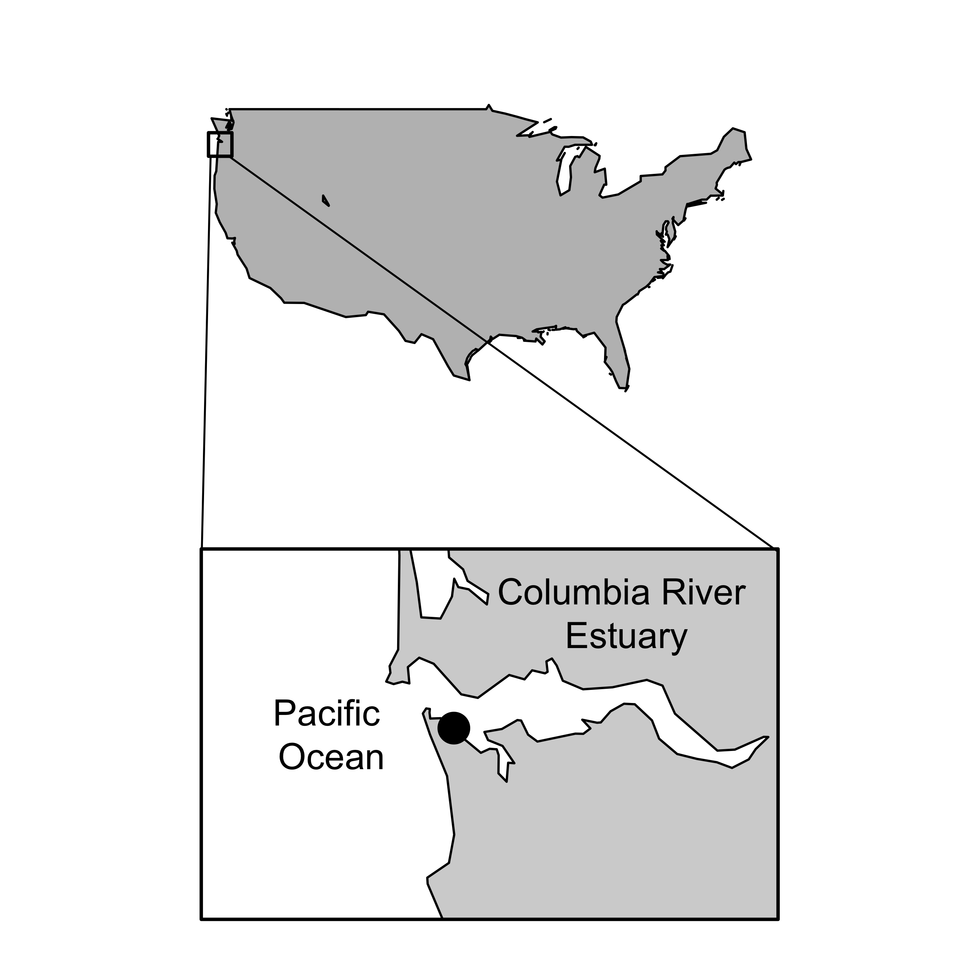

**Fig. 1** Map of the Columbia River Estuary with the sampling site location marked by the black dot.

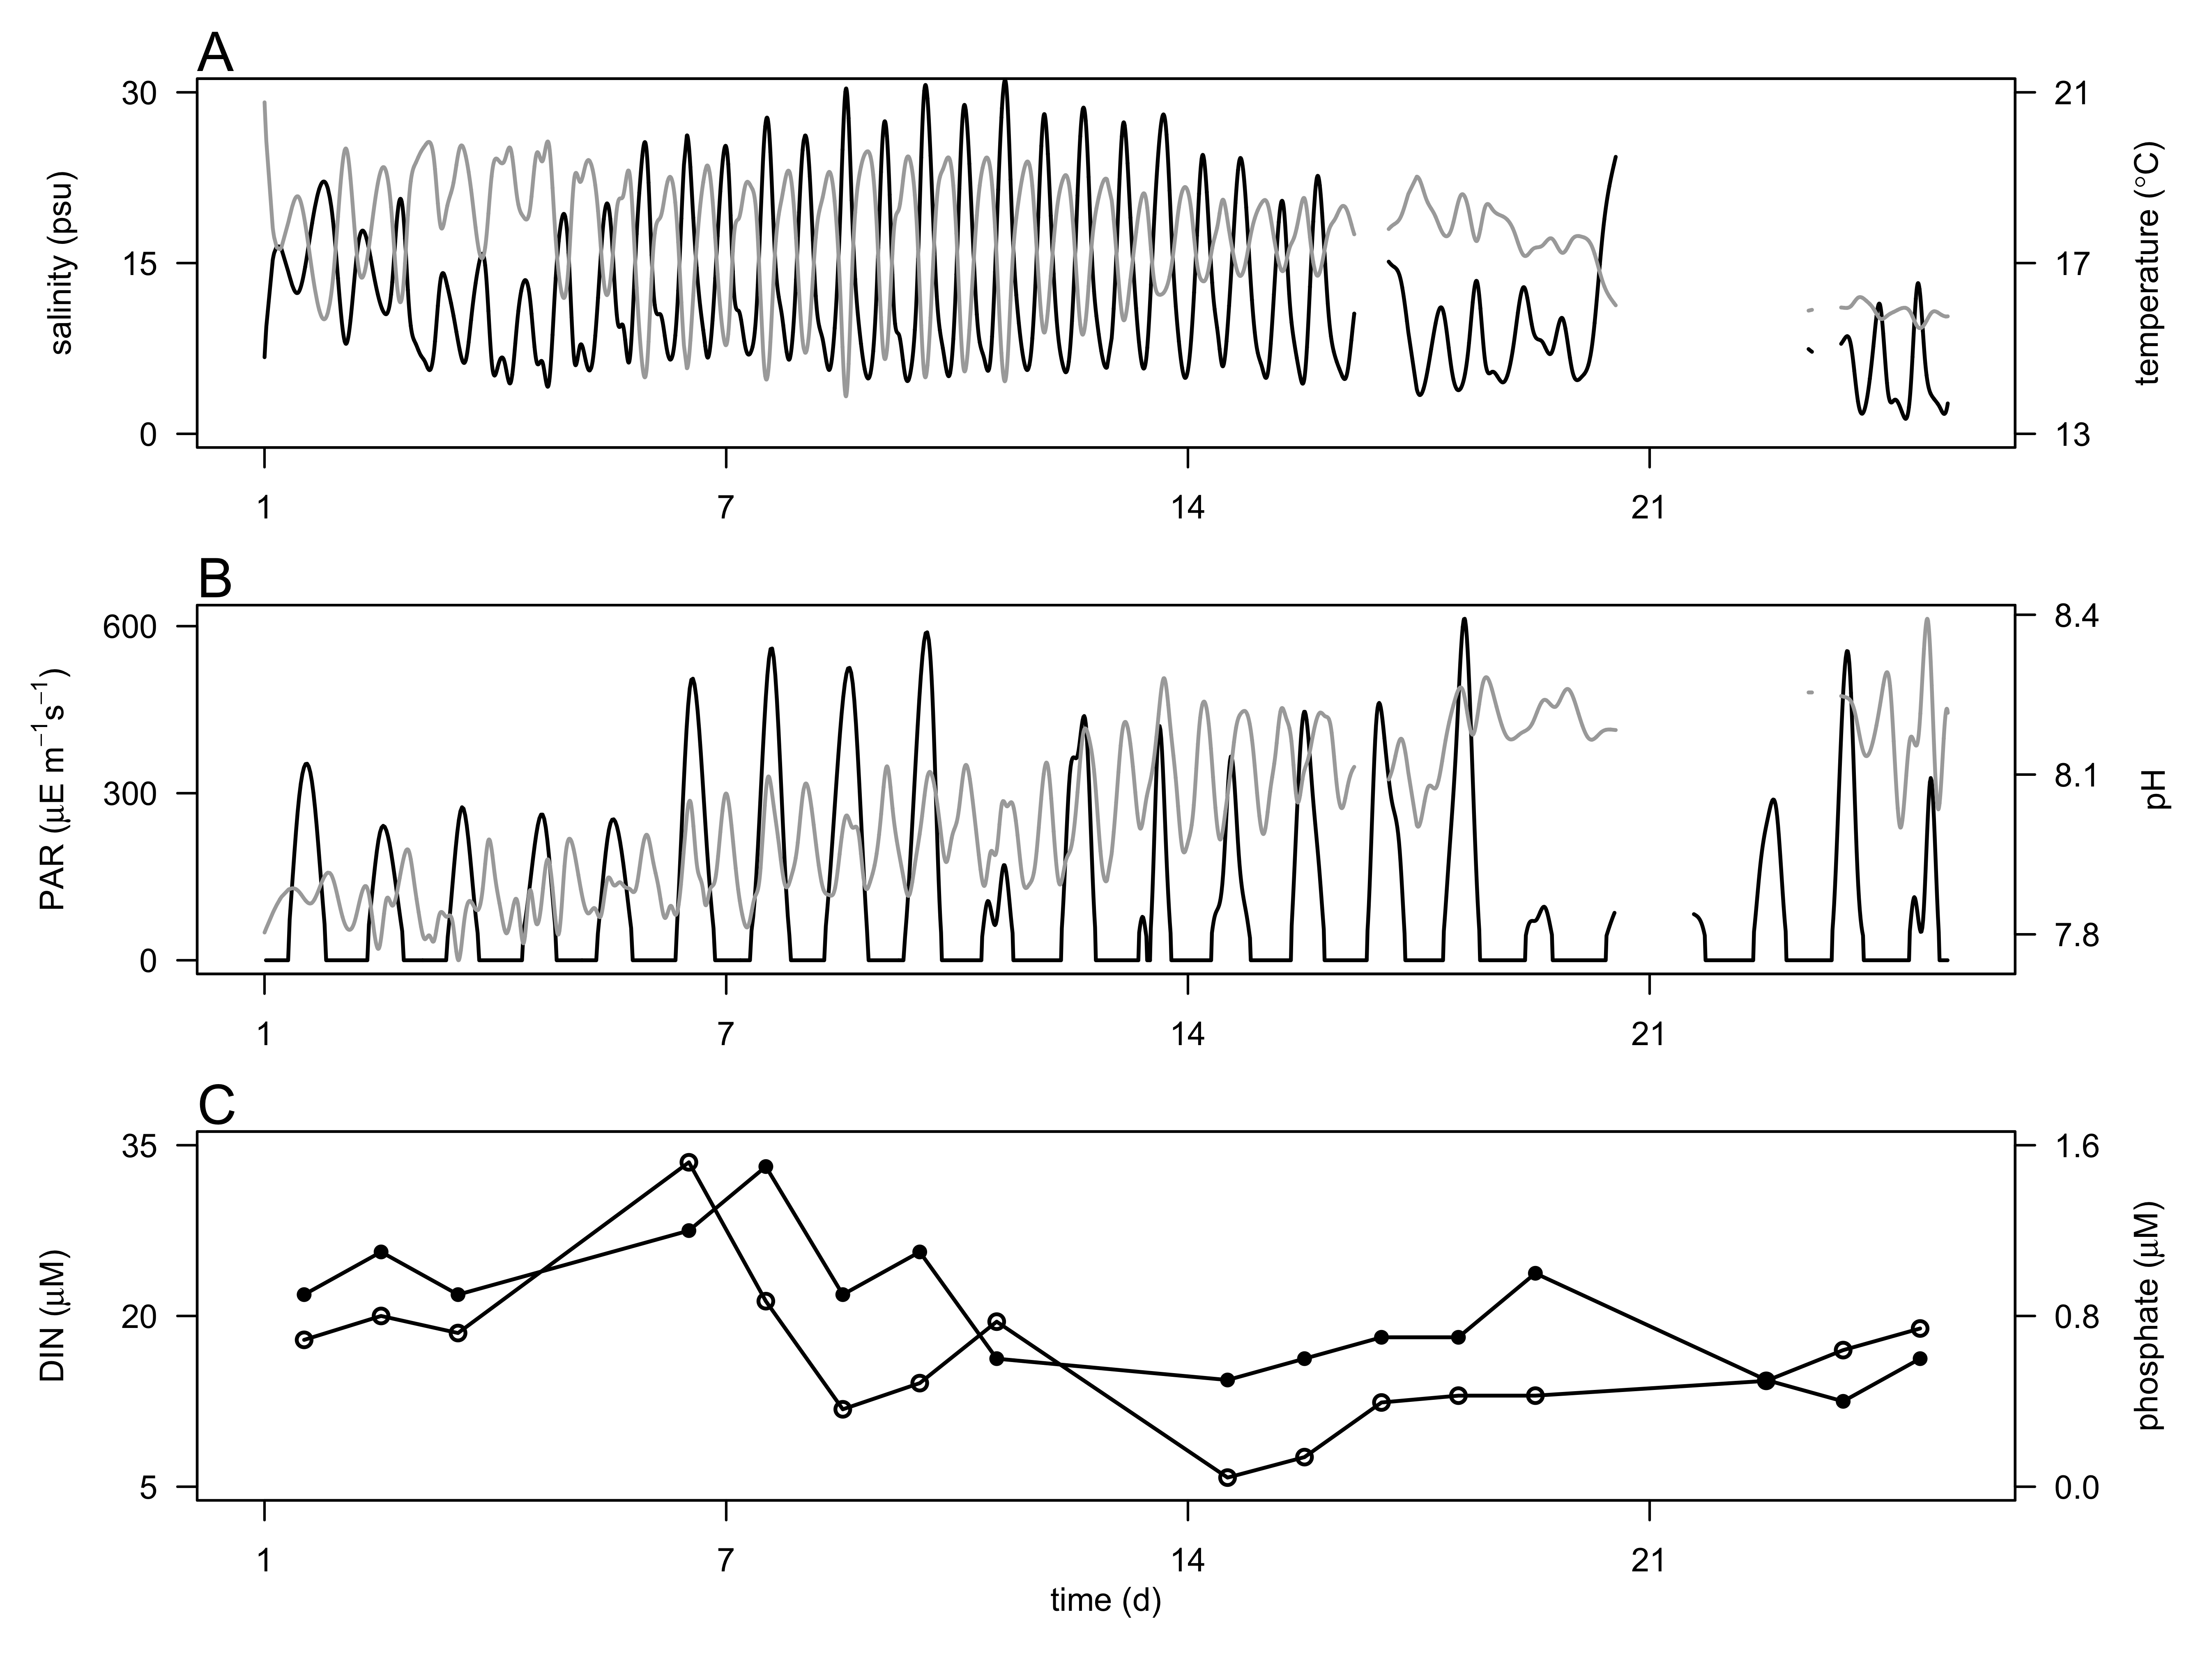

**Fig. 2** Hydrological conditions during the 4 week-survey in the CRE. A) Salinity (psu, black line) and temperature (ºC, grey line) at 3 m depth. B) Photosynthetic Active Radiations (PAR, µE m2 s-1, black line) in surface waters and pH (grey line), and C) concentrations of dissolved inorganic nitrogen (DIN, µM, open circle), and phosphate (µM, black circle) at 3 m depth.

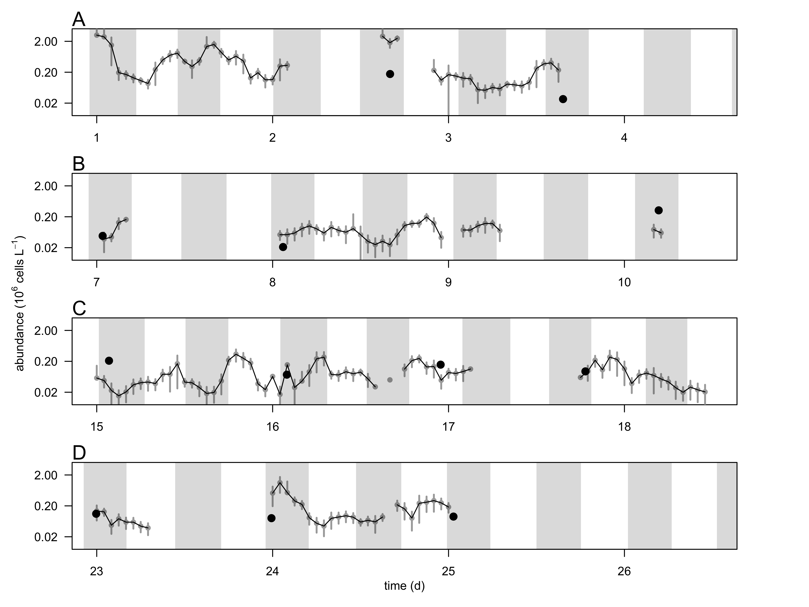

**Fig. 3** Hourly-averaged cell abundances of *Teleaulax* cryptophytes (grey circles and black line, 106 cells L-1) and abundance of *Mesodinium major* (black circles, 106 cells L-1) during the 4-week survey in the CRE (A-D). Vertical bars represent the standard deviation of the hourly-mean cell abundance (n=20). Grey regions represent flood tide. Gaps in the *Teleaulax* cell abundance occurred when the flow cytometer clogged due to high concentrations of suspended particle in the water.

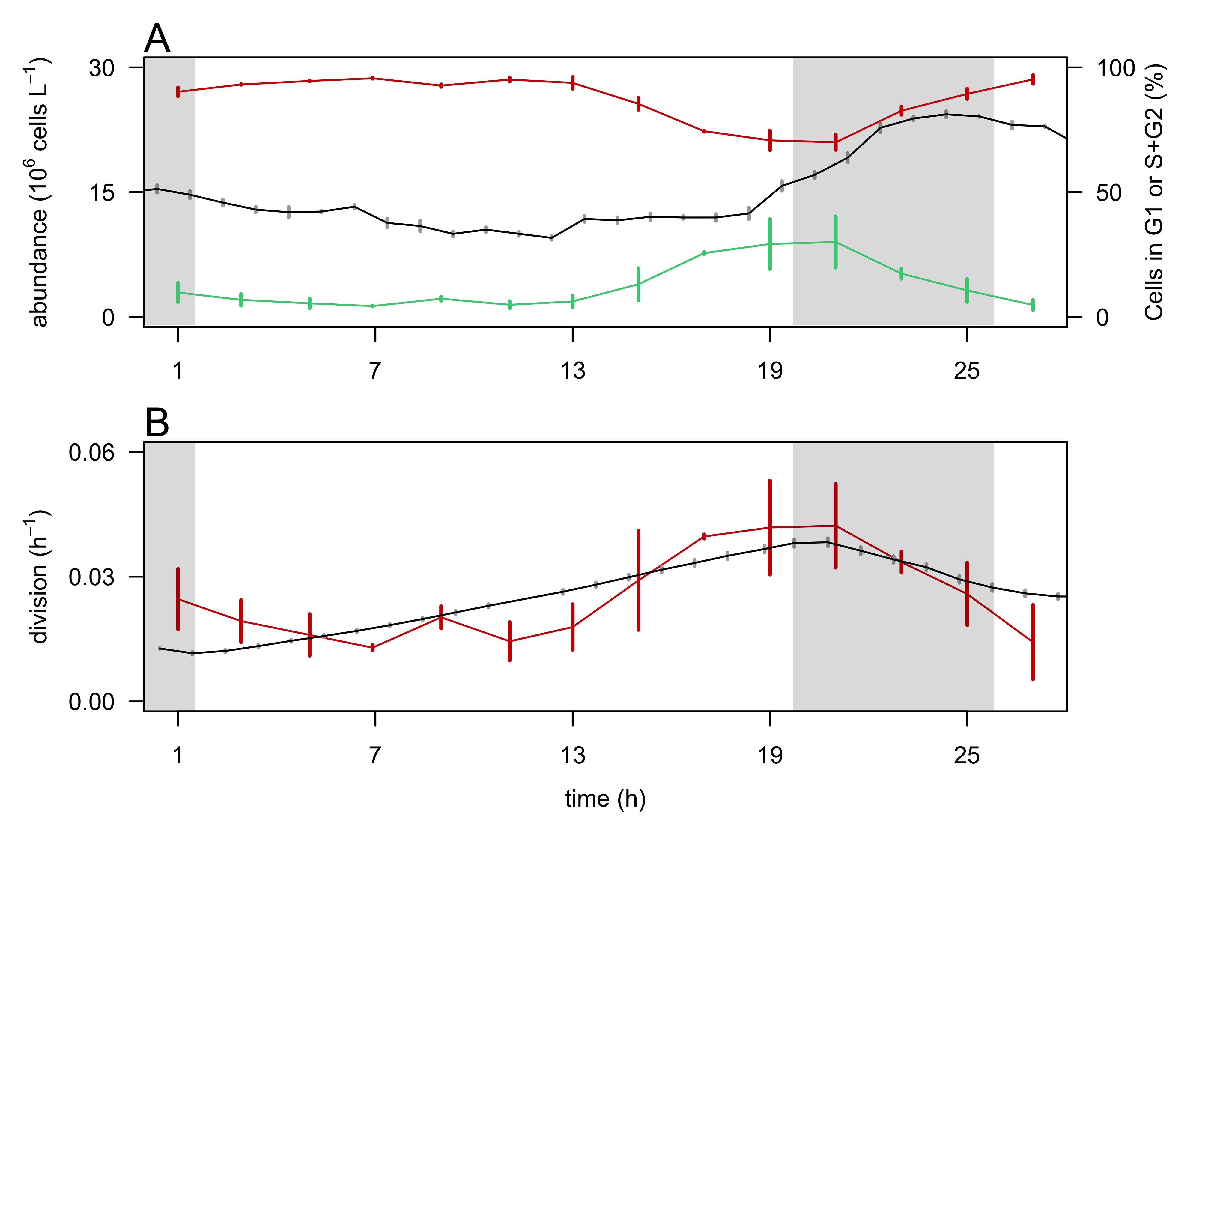

**Fig. 4.** Validation of the size-based division rate model with a cultured isolate during a 28-hr experiment.A) Hourly- averaged cell abundances of *Rhodomonas sp.* (106 cells L-1, black line) and percentage of cells in G1 (red line), and S+G2 (green line) phases. B) Hourly division rates (h-1) based on the relative proportions of cells in S+G2 phases (red line) and based on the size distribution (black line). The grey regions indicate night. Vertical bars represent standard deviations (n=20 for abundances, n=3 for the percent of cells in G1 and S+G2 phases, n=24 for the size-based division rates).

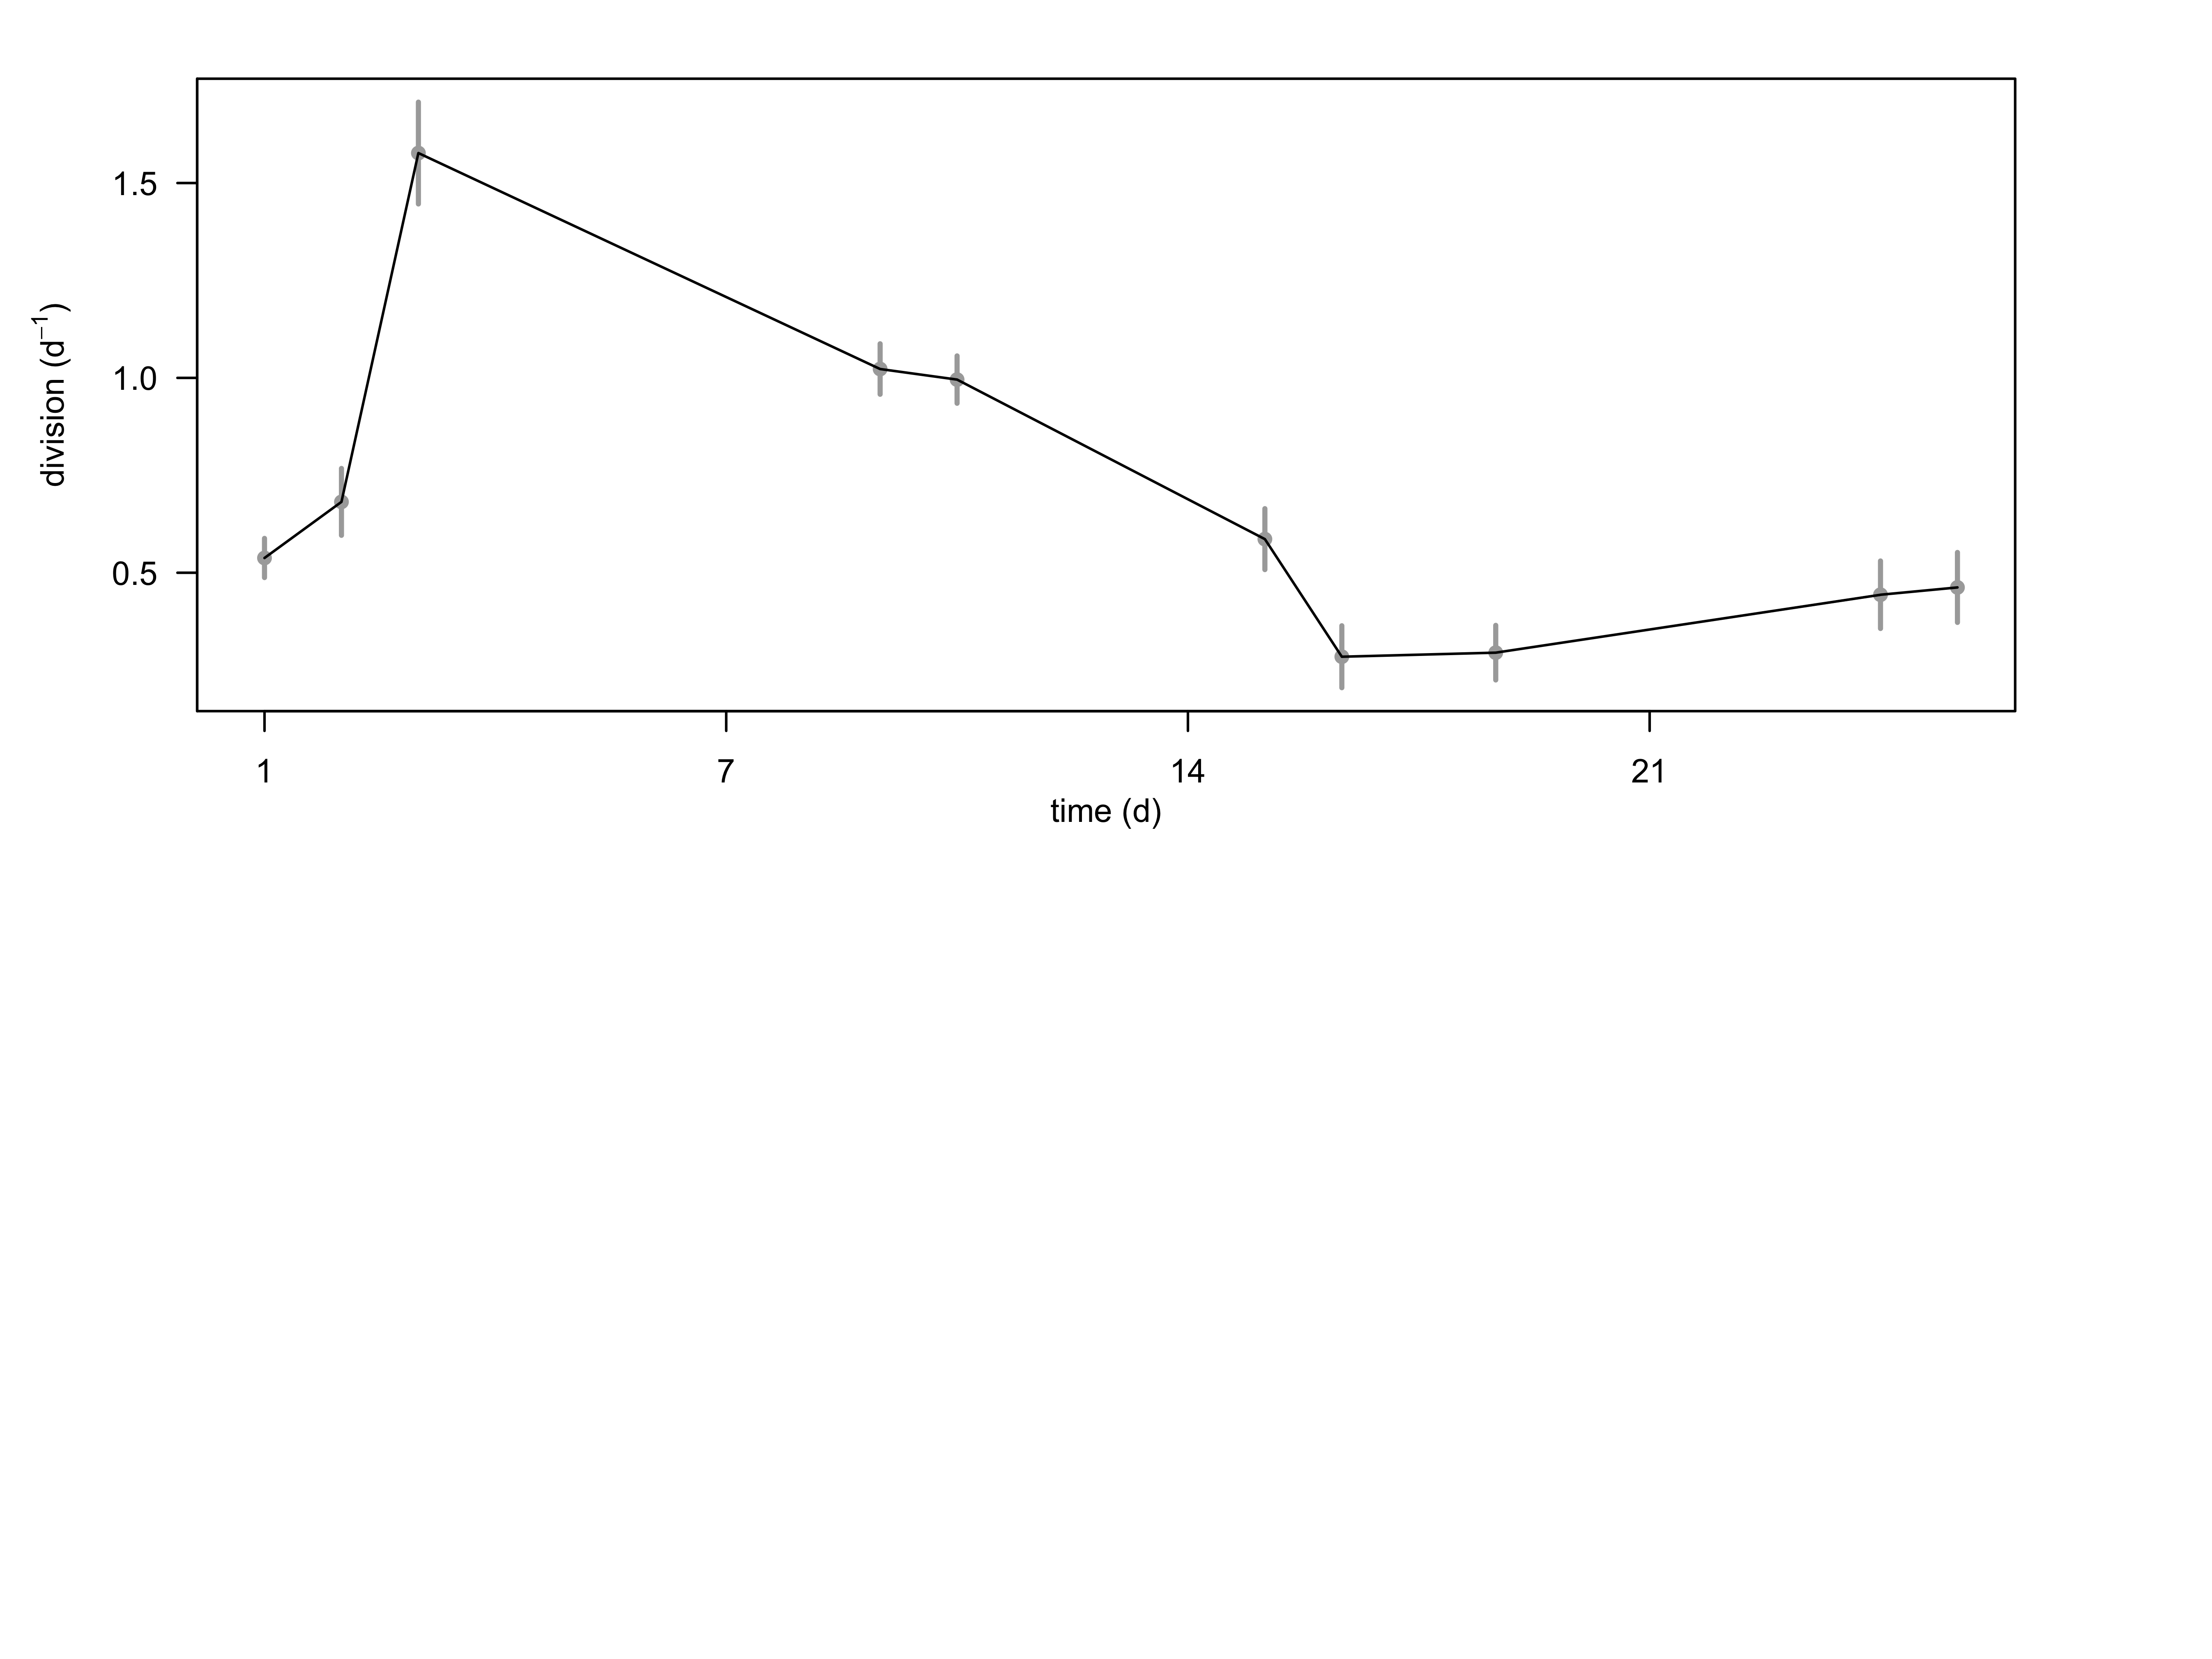

**Fig. 6** Daily division rates (d-1) of *Teleaul*ax cryptophytes during the survey in the CRE. Vertical bars represent the propagated standard error of the sum of hourly estimates during a 24 h-period.

*The following supplement accompanies the article*

**Dynamics of *Teleaulax* cryptophytes during red water blooms in the Columbia River Estuary**

**Maria Hamilton, Joseph Nedoba, Katie Maxey, Rhonda Morales, Tawnya Peterson, Megan Schatz, Jarred Swalwell, Peter Zuber, E. Virginia Armbrust, Francois Ribalet \***

* Corresponding author: [ribalet@uw.edu](mailto:ribalet@uw.edu)

*Marine Ecology Progress Series XXX: XX–XX (201X)*

**Supplement.**

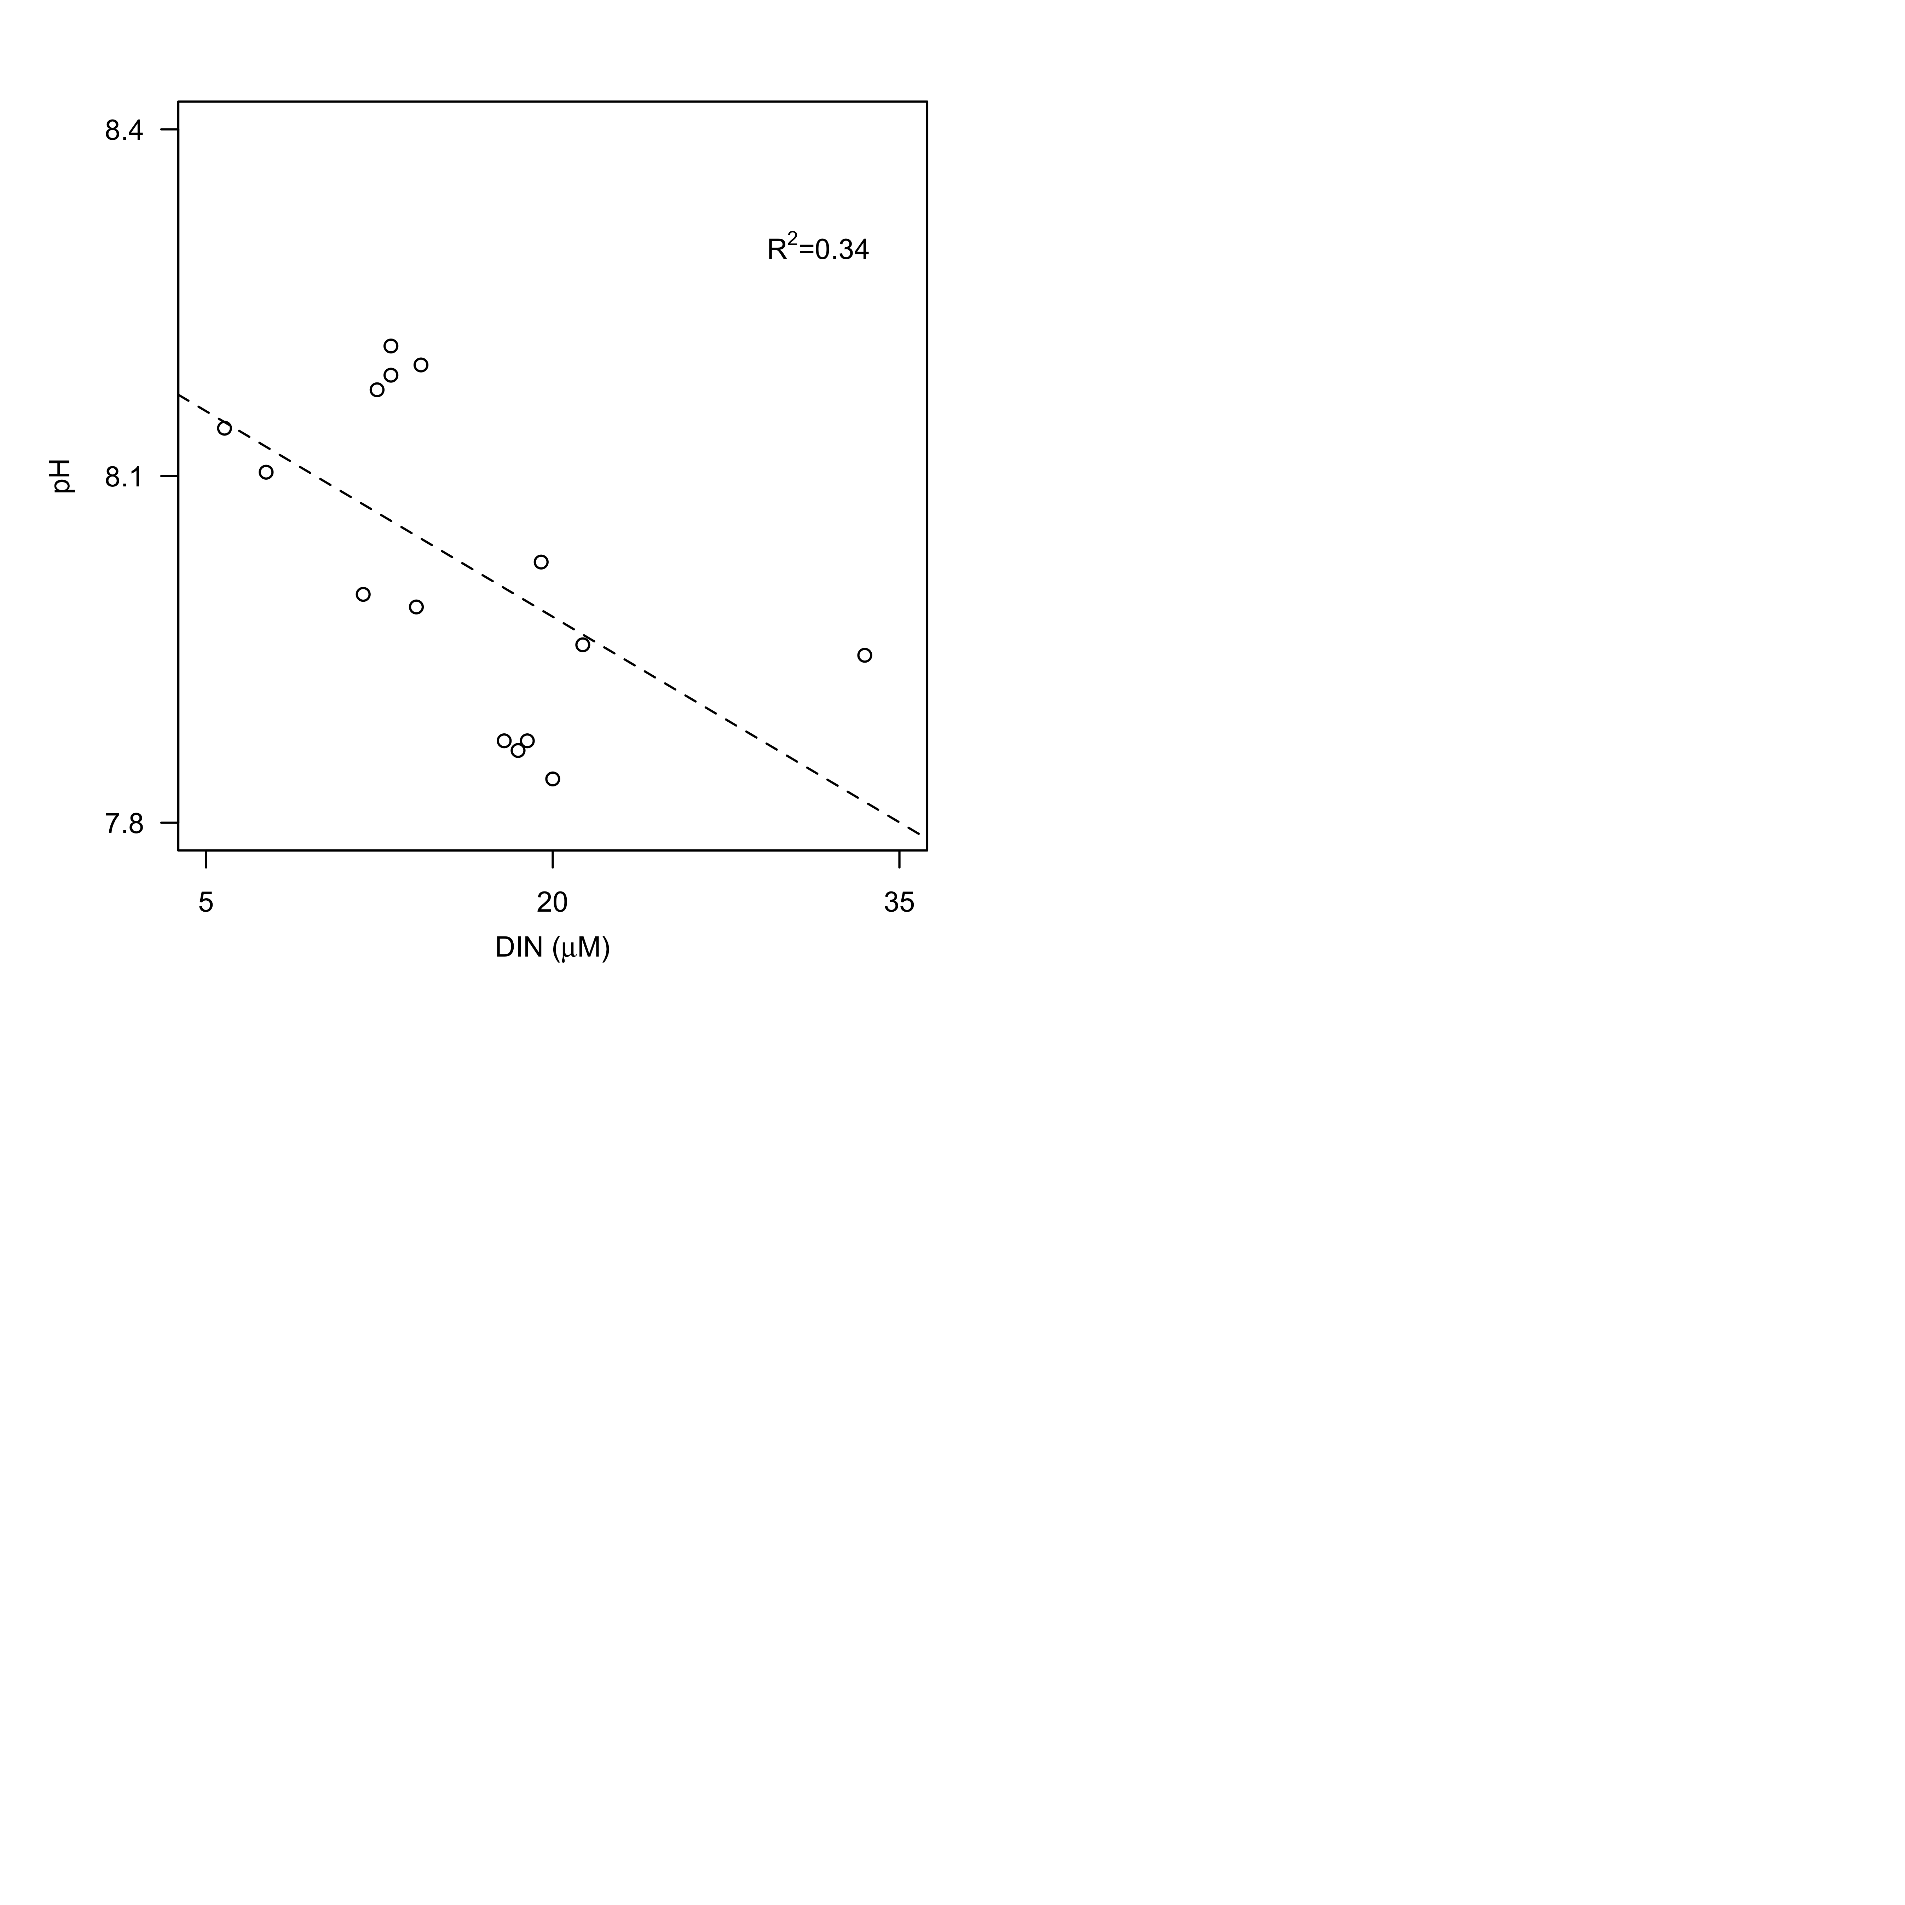

**Fig. S1** Relationship between pH and concentrations of dissolved inorganic nitrogen (DIN, as the sum of ammonium, nitrate and nitrite, µM). Dashed lines represent model II linear regression of plotted data and R2 represents the coefficient of determination.

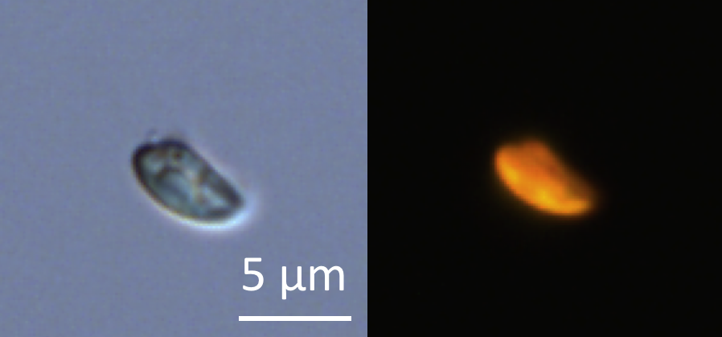

**Fig. S2.** Micrograph of glutaraldehyde-fixed *Teleaulax* cells using transmitted-light (A) and epifluorescence (B) microscopy after cell sorting by flow cytometry. Scale bar is 5 µm.

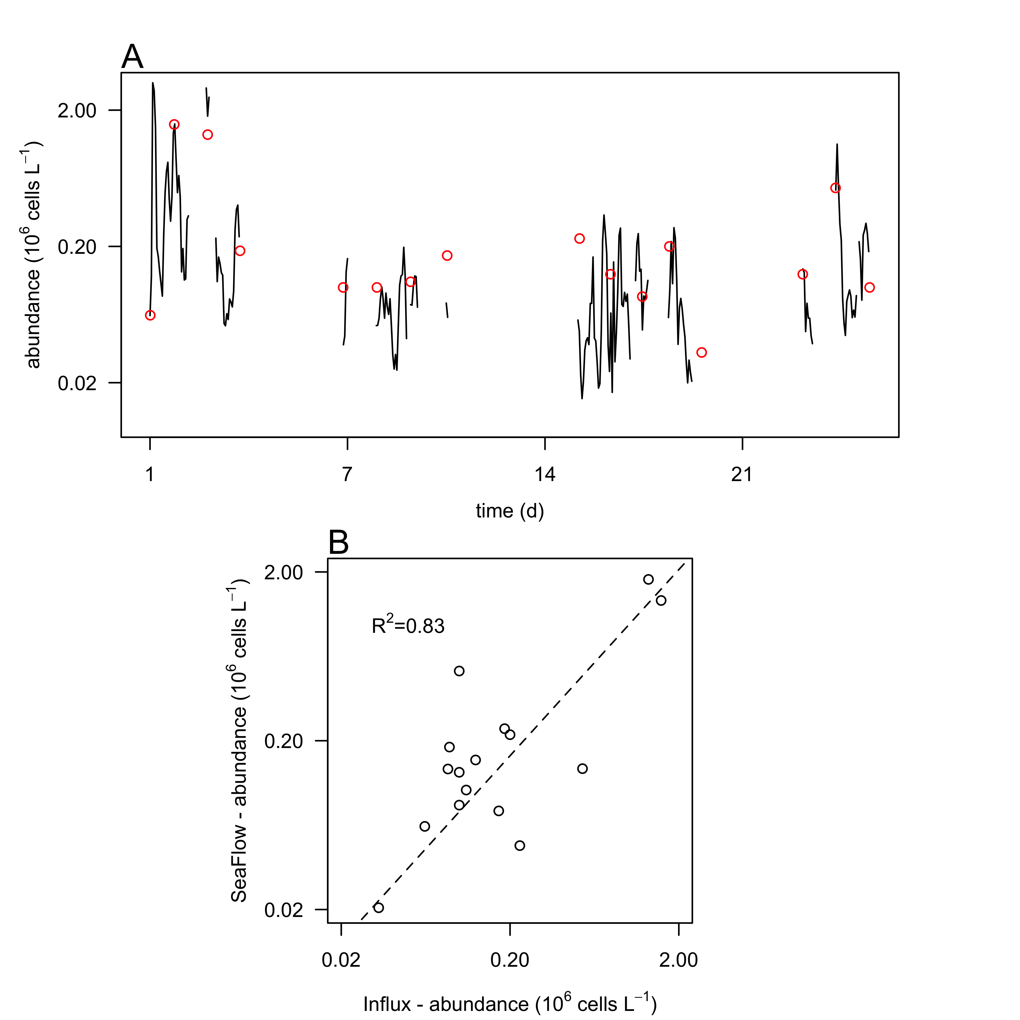

**Fig. S3.** Comparison of cell counts. A) Cell abundances of *Teleaulax* cryptophytes (106 cells L-1) during the survey measured with the SeaFlow instrument (black line) and measured with a BD Influx cell sorter (red circles). B) Correlation of cell abundances measured by the two instruments. Dashed lines represent model II linear regression of plotted data and R2 represents the coefficient of determination.

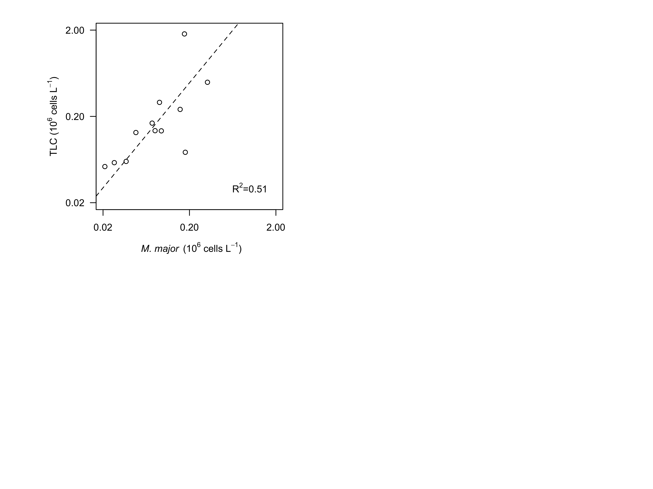

**Fig. S4** Relationship between hourly-average cell abundances of *Teleaulax* cryptophytes (TLC, 106 cells L-1)and abundances of *Mesodinium major* (*M. major*, 106 cells L-1) during the survey in the CRE. Dashed lines represent model II linear regression of plotted data and R2 represents the coefficient of determination.

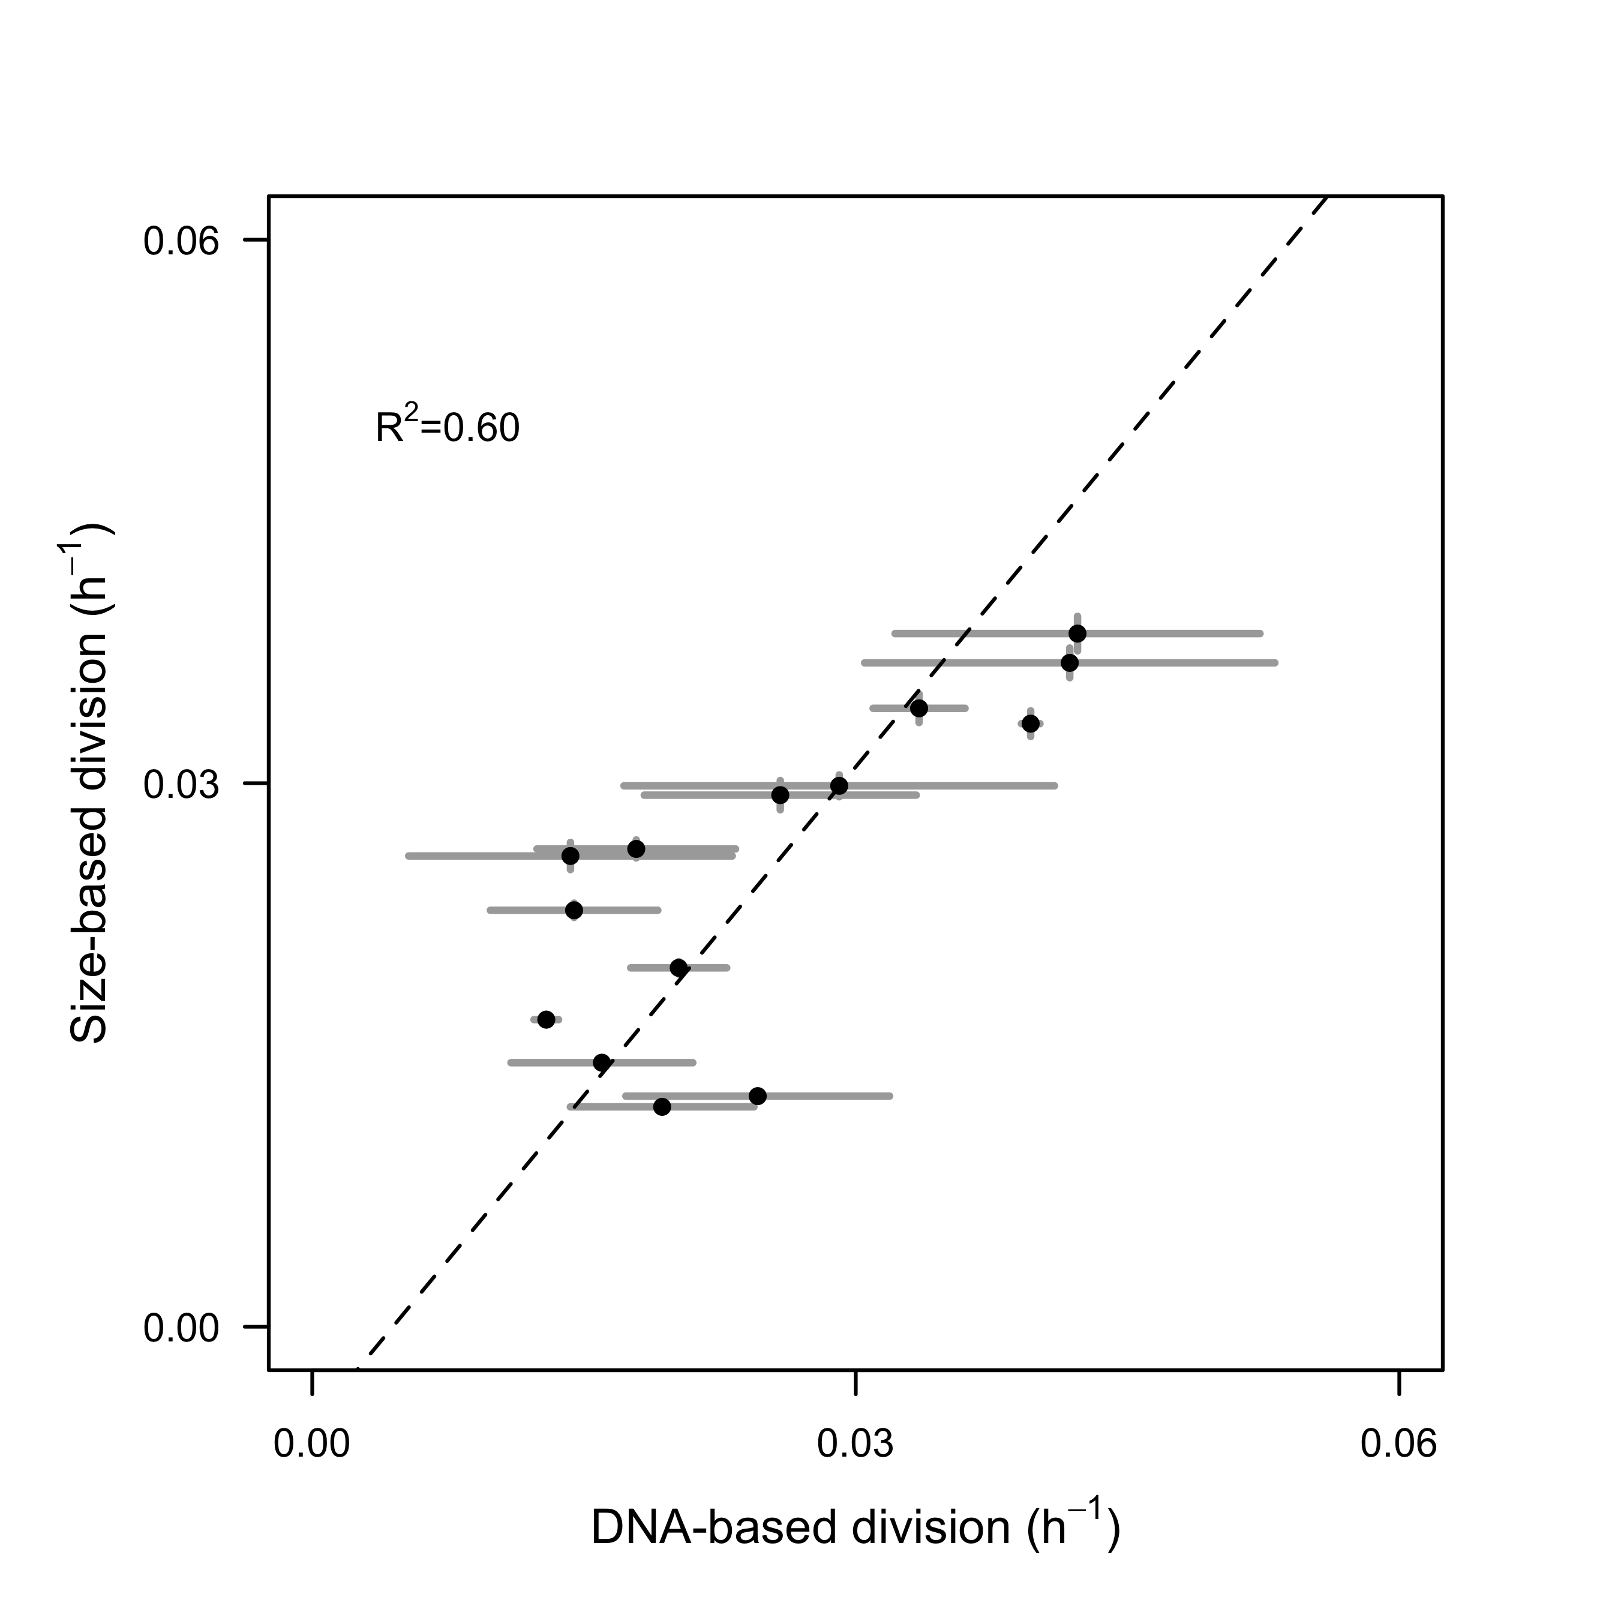

**Fig. S5.** Comparison of size-based division rate estimates (h-1) with DNA-based estimates of division rates (h-1) of *Rhodomonas sp* in cultures over the course of 28-hr. Dashed lines represent model II linear regression of plotted data and R2 represents the coefficient of determination.

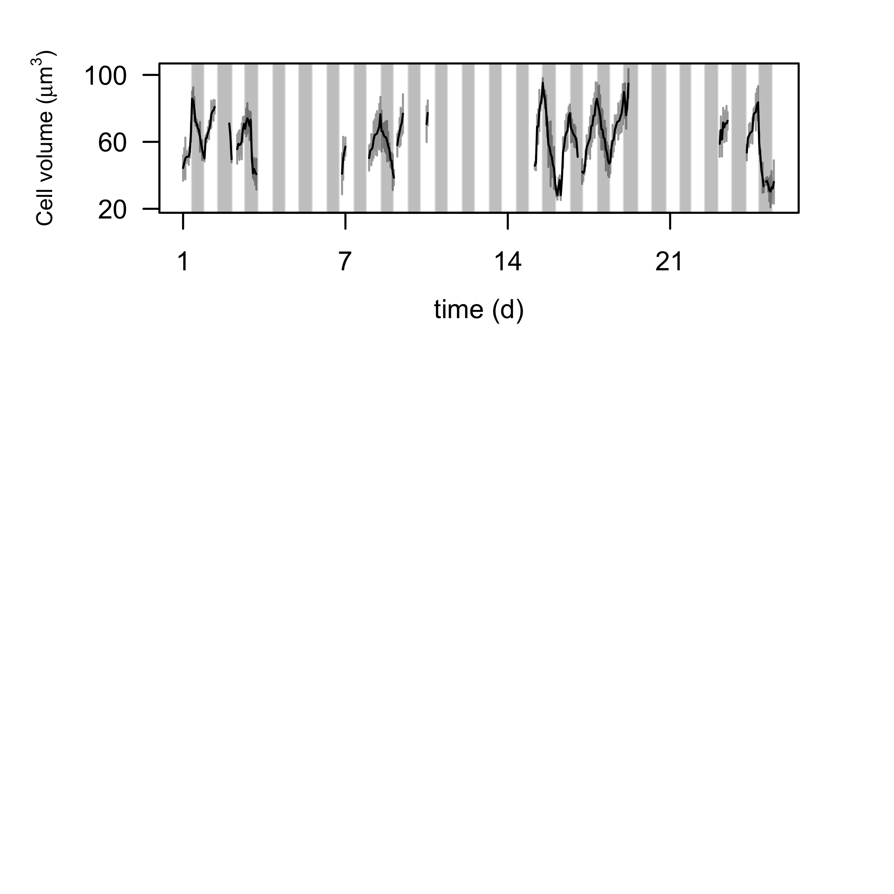**Fig. S6.** Hourly-averaged cell volumes of *Teleaulax* cryptophytes (µm3) estimated by SeaFlow during the survey. Vertical grey bars represent the standard deviation of the size distribution. The grey regions indicate night. The increase of cell volume during daylight and decrease of cell volume at night suggest that changes in cell volume are driven by photosynthesis and cell division, as assumed by the division rate model.

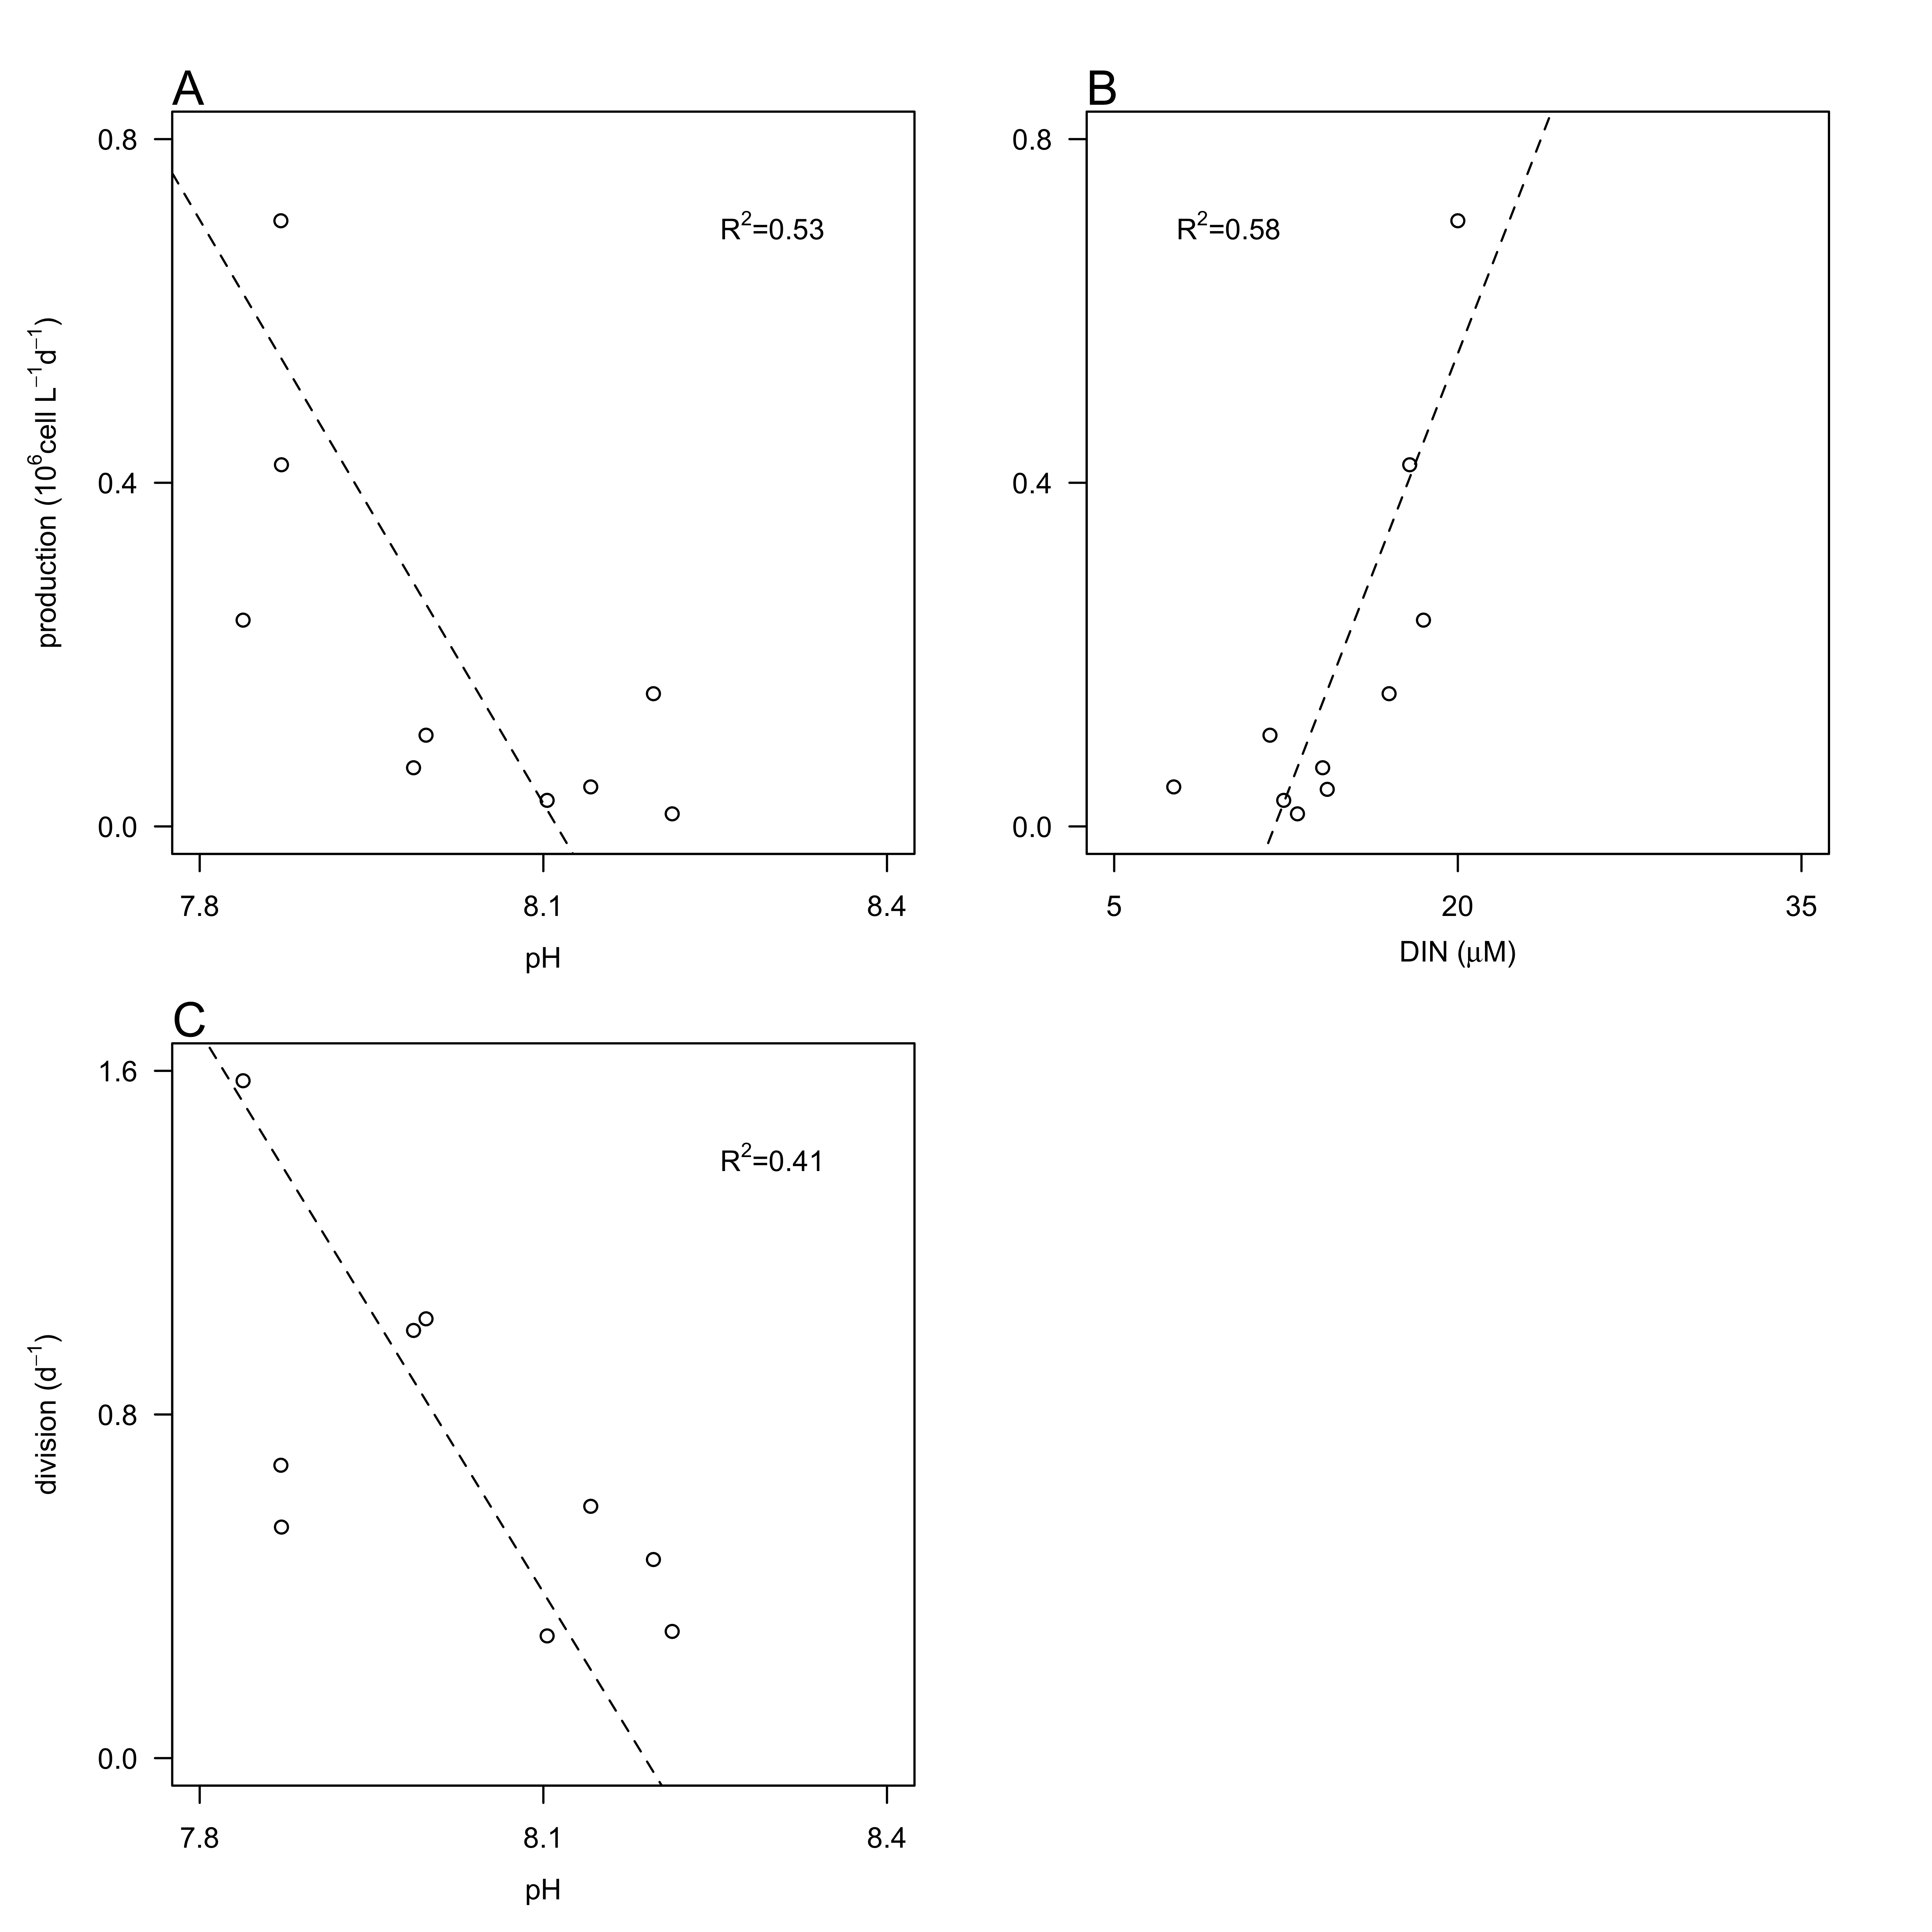

**Fig. S7** Relationship between cell production (106 cells L-1 d-1) of *Teleaulax* cryptophytes with A) daily-averaged pH (psu) and B) concentrations of dissolved inorganic nitrogen (DIN, µM) and between division rates (d-1) and pH during the survey. Dashed lines represent model II linear regression of plotted data and R2 represents the coefficient of determination.